Instructional unit
Ultimate Frisbee

Performance objective – what the student is expected to do at the end of the unit (One domain)
SWBAT demonstrate proper throwing and catching techniques, as well as utilize game-like strategies that will allow them to play in a modified game of Ultimate Frisbee.

Content that needs to be taught in order to meet the unit objective
Throwing –Backhand, forehand
Catching –Pancake
Lead Passing
Cutting to open space
Catching while moving
Passing against defense
Moving without the frisbee
Modified Game Play
Block plan – overview of what will be done in each day
Day | Content progression
1 | Introduction to Ultimate Frisbee  Pre/Post Assessment  Throwing – 1) Backhand,  Catching – 1) Pancake catch (two-handed)  Throwing For Distance
2 | Review of Backhand throw, pancake catch.  Lead Passing to moving target.  Formative Assessment – Skills Checklist
3 | Cutting to get open  Passing against defense  Ultimate in 10 Simple Rules Handout
4 | 3 Man Weave – Catching While Moving  Moving without the Frisbee  Exit Slip Cognitive Assessment
5 | Rule Review  Modified Ultimate Frisbee Game  Sliding Scale Assessment

Georgia State University PE Lesson Plan

Name: Kari Hunt | Date: 10/22/2011 | Semester: Fall 2011 | Class: 7240
Class/grade level: 7th |  | Date to be taught: 10/24/11
Unit/Theme: Ultimate Frisbee |  | Lesson #: 1 | Of: 5
# Of students: 28

Skills already developed by students:
This is the first lesson of the unit on ultimate frisbee so basic throwing and catching techniques will be introduced.
What happened during last lesson?
The last lesson did not relate to ultimate frisbee.
Lesson objective (s):
 | Domain | Performance | Situation | Criteria
1 | Psychomotor | SWBAT to perform a backhand frisbee throw | To a stationary partner standing 10 feet away | Based on a performance assessment rubric.
2 | Psychomotor | SWBAT to perform the ‘pancake’ two-handed catch. | From a stationary partner standing 10 feet away | Based on a performance assessment rubric.
3 | Affective | SWBAT to work cooperatively with a partner | During partner throwing task | 100%

State standard targeted (indicate standard(s), number(s) and write out standard(s)
PE7.1: Demonstrates competency in motor skills and movement patterns needed to perform a variety of physical activities.
PE7.2: Demonstrates understanding of movement concepts, principles, strategies, and tactics as they apply to the learning and performance of physical activities.
PE7.5: Exhibits responsible personal and social behavior that respects self and others in physical
activity settings.
Assessment for measuring performance criteria
1. Students will attempt to perform the backhand frisbee throw to a partner from 10 feet away and will be assessed on their ability to demonstrate the proper technique based on an established rubric (see attached).
2. Students will attempt to perform the pancake catch with a frisbee thrown by a partner from 10 feet away and will be assessed on their ability to demonstrate the proper technique based on an established rubric (see attached).
My goal for improving my teaching
I want to make sure to check students for understanding (CFU) to make sure the skills/cues of the task being taught are being learned.

Equipment and resources needed
-15 Frisbees minimum (enough for partner drills). Ideally 1 frisbee per student.
-Cones
Alternative activities for students with special needs (those unable to participate in regular activities with modifications)
Adaptive strategies will be implemented if necessary.
For example, everyone can practice throwing/catching but assistance may be needed with retrieving frisbees (ex: if in wheelchair).
Instructional / practice time / organization (see other side)

Time | Activity/Task Development/Safety Issues | Organization Management | Critical Elements/Teaching Prompts | Reflection
2 mins.  8:35-8:37 | Set Induction (for Task #1)  SIGNALS & DEMONSTRATIONS  (Min. of 2 demos) | Students will be lined up in a semi-circle format outside.  “Same” | -Has anyone seen frisbee golf or an ultimate frisbee game? How many of you have played ultimate frisbee before? How many of you have thrown a frisbee before? (INTEREST)  -First we will be working on the proper way to throw a frisbee. (FOCUS)  -Throwing a frisbee is the most basic skill you can have if you want to partake in any of these activities. We will play modified games and potentially full games of ultimate frisbee at end of the unit, but being able to throw a frisbee properly and accurately will help you if you want to be able to play this sport recreationally or competitively. (REASONS)  -By the end of the lesson today, I would like you to be able to properly demonstrate the backhand throw to your partner using the performance cues provided. (OBJECTIVE)  After this demonstration on “GO”, one person out of each set of partners will pick up a frisbee and stand facing your partner 10 feet apart. We will go through cues together and then you will throw the frisbee back and forth to your partner. When you hear the whistle you will end the task and place frisbee on the ground in front of you. CFU (Check for understanding of cues).
10 mins.  8:37-8:47 | Task #1: Throwing In Pairs | People = Partners (14 sets of 2)  Spacing = Students will line up approximately 10 feet apart on the field. Use cones to set distance.  Time = 10 minutes  Equipment = See above. | Teaching Cues for Backhand  1) Grip – Thumb on top and four fingers underneath w/ four fingertips touching inside of rim.  2) Stance – Throwing shoulder towards target.  3) Step – Step with same foot as the throwing hand and transfer weight. Extend reach.  4) Spin – Snap your wrist and get a lot of spin. Do not use arm to get more spin.  Teaching Cues for Pancake Catch  1) Extend your arms and open your hands.  2) Catch the disc with your palms, not your fingers.  3) Do not use body to trap disc. | Next time I do this partner drill, I need to use more of the field space or stagger the partners since many of the throws were not staying between the two partners (safety issue).
10 mins.  8:47-8:57  *If time permits | Task # 2: Throwing for Distance/Accuracy  Task # 3: Throwing to moving target/teammate (lead passing) | People = See above  Spacing = 10 feet away but will move farther away with complete passes.  Time = 10 minutes.  Equipment = See above.  People = Same | Same TEACHING CUES as above.  With completed pass, receiver will take one step back. With missed catch, receiver will take one step forward.  Lead Passing will be introduced. One student will be the ‘wide receiver’ and will run out, make a cut, and try to catch a pass. The ‘quarterback’ will lead the receiver by throwing the frisbee ahead of them. | Did not get to Task #3.
3 mins.  8:57-9:00 | CHECK FOR UNDERSTANDING & LESSON CLOSURE |  | CFU on cues for Backhand, Pancake Catch.  Closing Questions:  1) What foot should you step with when throwing a disc? (same foot as throwing hand).  2) If you are going to throw any kind of throw w/ a disc, what do you need for it to fly flat and far? (spin).  3) What must you do with your hand or arm to get more spin? (flick your wrist)  4) What is the most common way to throw a frisbee? (backhand).

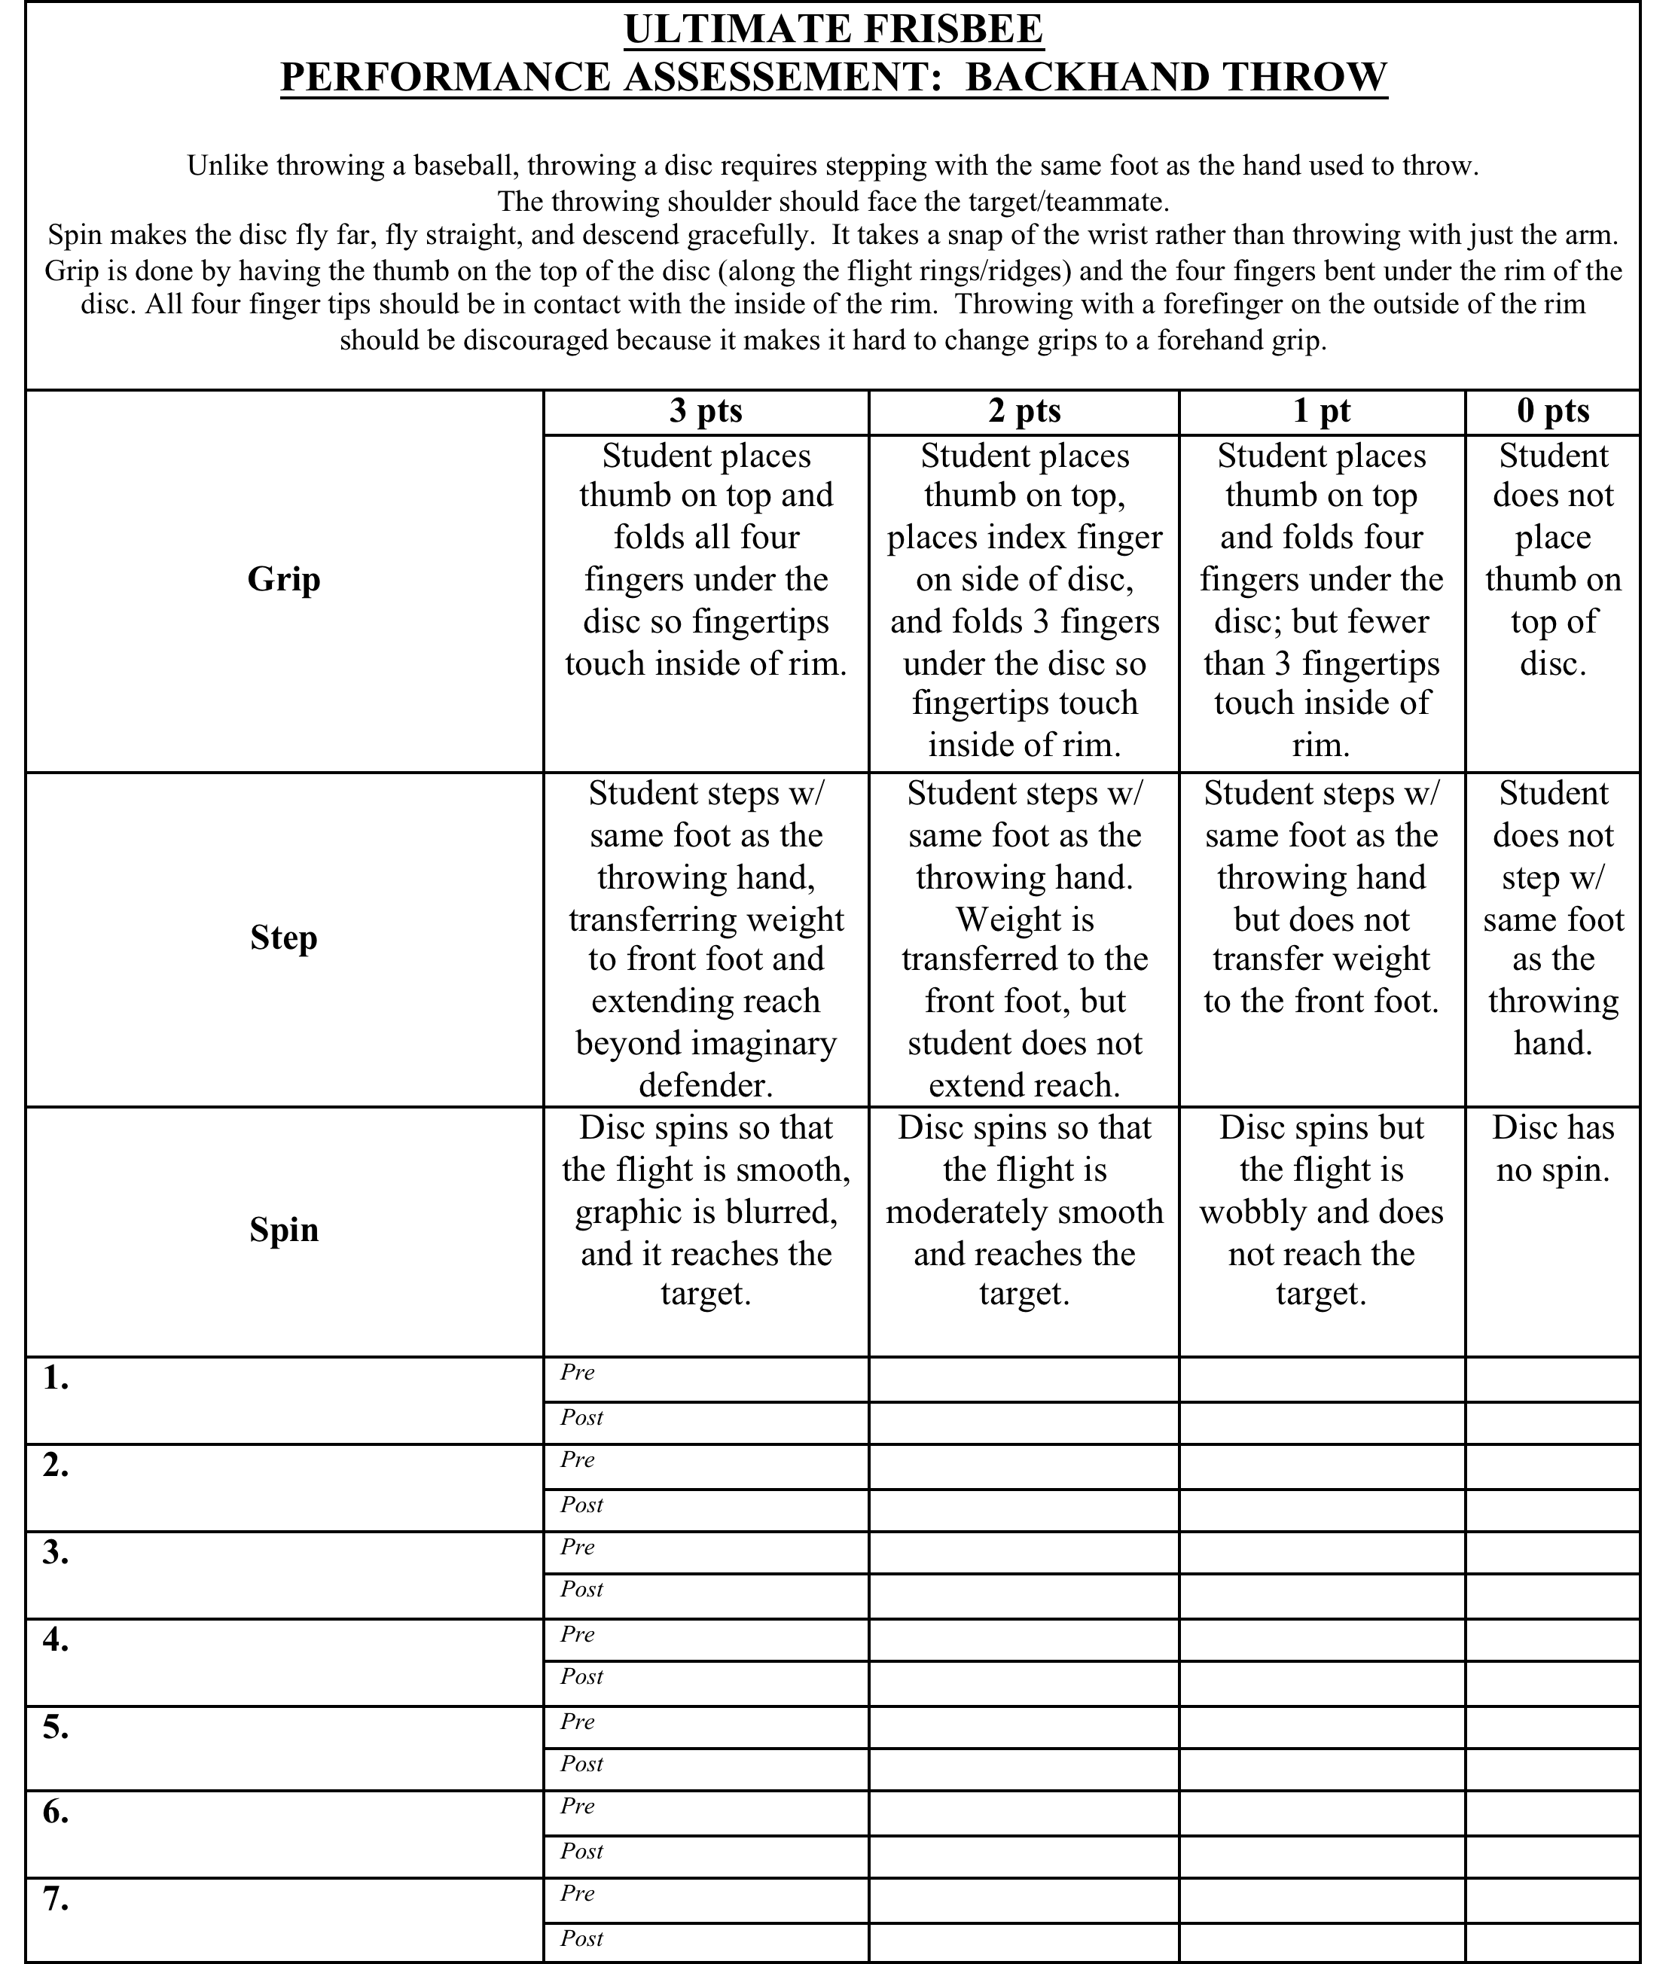

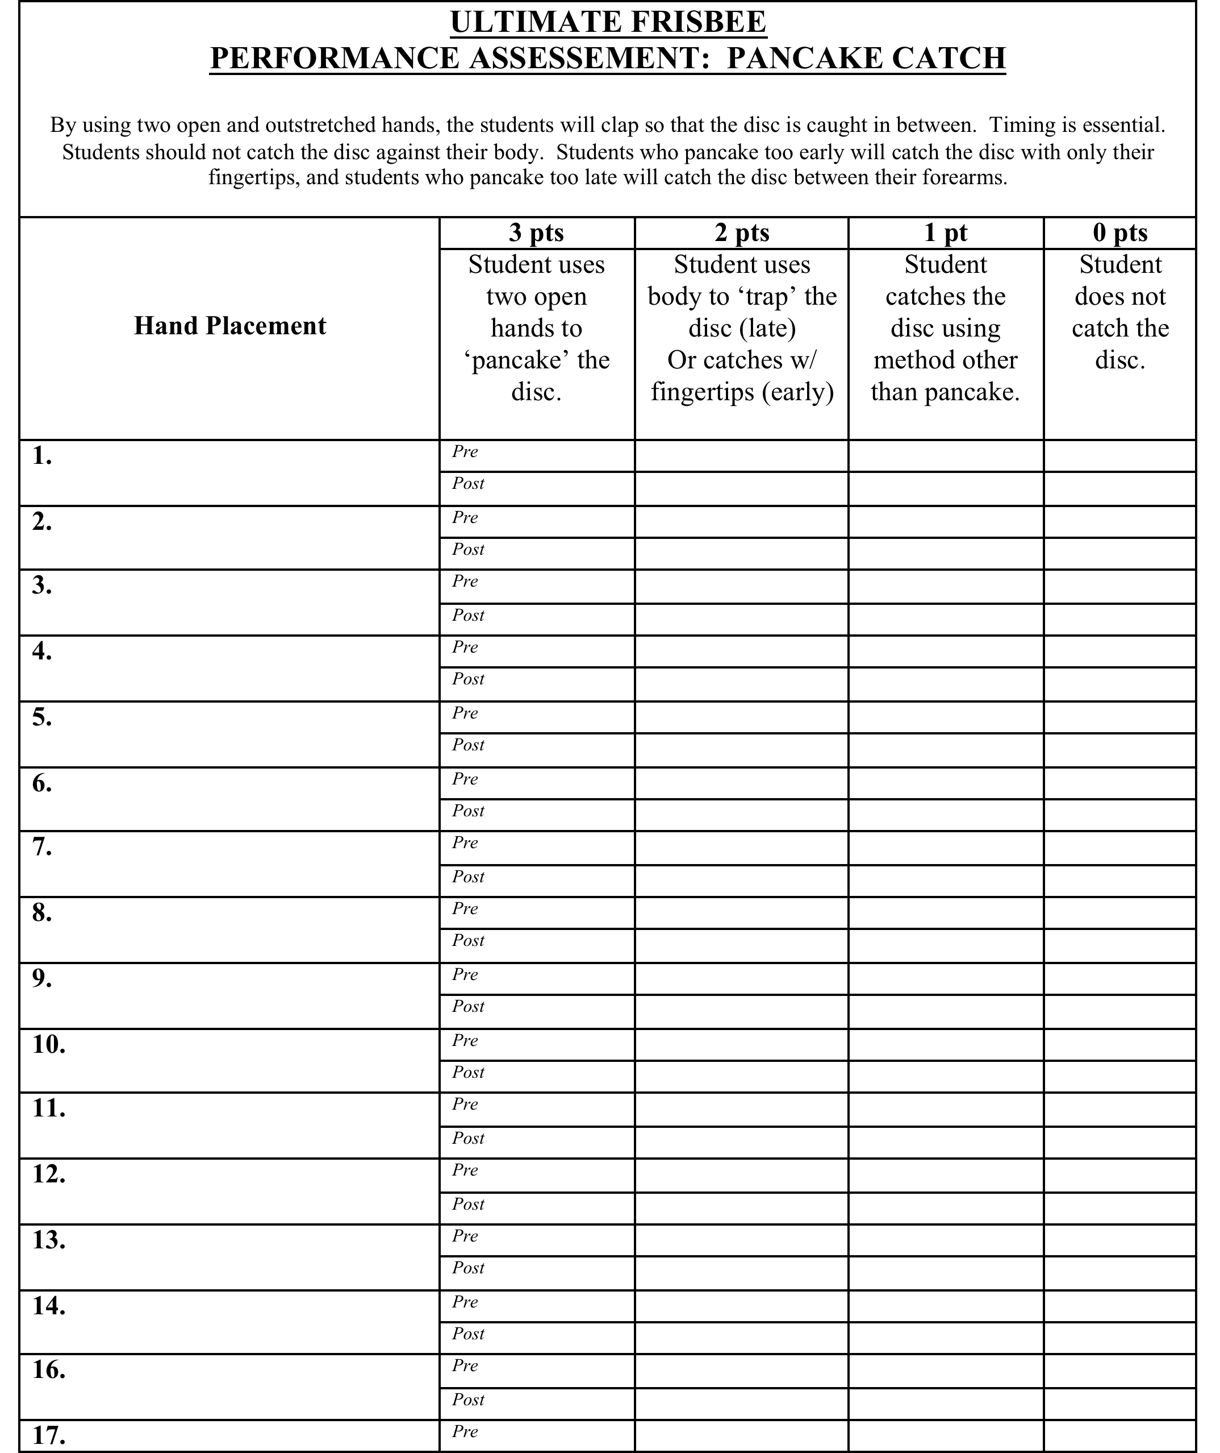
Georgia State University PE Lesson Plan

Name: Kari Hunt | Date: 10/22/2011 | Semester: Fall 2011 | Class: 7240
Class/grade level: 7th |  | Date to be taught: 10/25/11
Unit/Theme: Ultimate Frisbee |  | Lesson #: 2 | Of: 5
# Of students: 28

Skills already developed by students:
Students have worked on basic catching (pancake/alligator catch) and backhand throw.
What happened during last lesson?
The last lesson was an introduction to the mechanics of throwing and catching.
Lesson objective (s):
 | Domain | Performance | Situation | Criteria
1 | Cognitive | SWBAT demonstrate knowledge of the cues for backhand throw and pancake catch | When prompted or asked by the teacher | 100%
2 | Psychomotor | SWBAT properly demonstrate a lead backhand pass | To their partner that is moving | 4 out of 5 times (80%)
3 | Affective | SWBAT to work cooperatively with a partner | During all tasks and drills | 100%

State standard targeted (indicate standard(s), number(s) and write out standard(s)
PE7.1: Demonstrates competency in motor skills and movement patterns needed to perform a variety of physical activities.
PE7.2: Demonstrates understanding of movement concepts, principles, strategies, and tactics as they apply to the learning and performance of physical activities.
PE7.5: Exhibits responsible personal and social behavior that respects self and others in physical
activity settings.
Assessment for measuring performance criteria
Teacher will do a simple formative assessment by using a skill checklist to assess the students’ ability to properly demonstrate a lead backhand pass to a moving target.
Skill Observed at least 4 out of 5 times?
Performance assessment based on 3 components:
1) Backhand Throw Technique
- Grip
- Stance
- Step
- Spin
2) Frisbee Is Thrown Ahead (not behind) Moving Partner
3) Partner is able to attempt a catch while in stride (does not have to slow down or speed up too much).
My goal for improving my teaching
I want to review and stress the proper technique for throwing to make sure the students utilize it from this point forward in the unit. To improve, I will try to use more pinpointing and feedback during the lesson.
Equipment and resources needed
-15 Frisbees minimum (enough for partner drills).
-Cones
Alternative activities for students with special needs (those unable to participate in regular activities with modifications)
Adaptive strategies will be implemented if necessary.
Possibly pair off students based on abilities so there isn’t as much disparity in the drills.
Instructional / practice time / organization (see other side)

Time | Activity/Task Development/Safety Issues | Organization Management | Critical Elements/Teaching Prompts | Reflection
2 mins.  8:35-8:37 | Set Induction (for Task #1)  SIGNALS & DEMONSTRATIONS  (Min. of 2 demos) | Students will be lined up in a semi-circle format. | -Yesterday we worked on the fundamentals of throwing and catching. Are there any questions on what we went over yesterday? Who can remember the cues for backhand throw? And for the pancake catch? (INTEREST)  -Today we will review those cues for effective throwing and catching and will also build on that by working on distance throwing and lead passing. (FOCUS)  -It is one thing to be able to pass to a target that is not moving or that is 5-10 feet away from you. However, ultimate frisbee is a very spread out game and if you have ever seen the game played, none of the players ever really stand still. (REASONS)  -By the end of the lesson today, I would like you to be able to properly demonstrate a lead backhand pass to your partner 4 out of 5 times. (OBJECTIVE)  Same start/stop signals are used (whistle), as well as equipment ready position for the students between tasks.  Review/Quick Demos of Cues from Lesson 1:  Pancake Catch  Backhand throw
5 mins.  8:37-8:42 | Task #1: Skill Review – Partner Passing | People = Partners (14 sets of 2)  Spacing = Students will line up approximately 10 feet apart on the field. Use cones to set distance.  Time = 10 minutes  Equipment = See above. | CFU:  1) What foot should you step with when throwing a disc? (same foot as throwing hand).  2) Should you use more arm to get more distance or spin? (No – you flick your wrist)  3) Why is it important to follow through on your throw?  4) What is the most common way to throw a frisbee? (backhand).
10 mins.  8:42-8:52 | Task # 2: Throwing to moving target/teammate (lead passing) | People = See above  Spacing = Starting 10 feet away spaced out on the field.  Time = 10 minutes.  Equipment = See above. | Lead Passing will be introduced. One student will be the ‘wide receiver’ and will run out, make a cut, and try to catch a pass. The ‘quarterback’ will lead the receiver by throwing the frisbee ahead of them. The partners will switch roles after five throws each.  Cues for lead passing:  - Timing –  The frisbee needs to be thrown in front of the teammate, not AT the teammate.  - Partner Stride –  Partner should be able to attempt a catch while in stride (does not have to slow down or speed up too much).
6 mins.  8:52:8:58 | Task #3: Rapid Fire Target Throw | People = 3 lines  Spacing = 30 feet from target. | Students took a turn aiming at target approximately 30 feet away. They recalled the technique (more flick of the wrist, more transfer of weight) to add distance to their backhand throws and were given one opportunity at the end of the lesson to get closest to the target. | Was added in at the last minute, but students seemed to enjoy it.
2 mins.  8:58-9:00 | CHECK FOR UNDERSTANDING & LESSON CLOSURE |  | Essential Question for lesson: Why is it important to have timing on offense when you are the person w/ the frisbee, or when you are the person w/ out the frisbee?

Georgia State University PE Lesson Plan

Name: Kari Hunt | Date: 10/23/2011 | Semester: Fall 2011 | Class: 7240
Class/grade level: 7th |  | Date to be taught: 10/26/11
Unit/Theme: Ultimate Frisbee |  | Lesson #: 3 | Of: 5
# Of students: 28

Skills already developed by students:
Fundamental passing, catching. Cutting and lead passing as offensive strategies.
What happened during last lesson?
Backhand throwing to a moving target. Worked on timing and execution of pass.
Lesson objective (s):
 | Domain | Performance | Situation | Criteria
1 | Psychomotor | SWBAT properly demonstrate a cutting pattern | To free themselves for a pass in general space | 4 out of 5 times (80%)
2 | Psychomotor | SWBAT properly demonstrate a fake | While making a pass with defense | 4 out of 5 times (80%)
3 | Affective | SWBAT to work cooperatively with a partner | During all tasks and drills | 100%

State standard targeted (indicate standard(s), number(s) and write out standard(s)
PE7.1: Demonstrates competency in motor skills and movement patterns needed to perform a variety of physical activities.
PE7.2: Demonstrates understanding of movement concepts, principles, strategies, and tactics as they apply to the learning and performance of physical activities.
PE7.5: Exhibits responsible personal and social behavior that respects self and others in physical
activity settings.
PE 7.6: Values physical activity for health, enjoyment, challenge, self expression, and/or social-
interaction.
Assessment for measuring performance criteria
Students will answer two questions at the end of the lesson to show evidence of learning.
My goal for improving my teaching
To use less time for instruction (or at least be more concise) to allow for additional playing time and activity time. Maximize the time the students are engaged.
Equipment and resources needed
-15 Frisbees minimum (enough for partner drills).
-Cones
Alternative activities for students with special needs (those unable to participate in regular activities with modifications)
Accommodations will be made to make lesson inclusive for all students. Drills can be adjusted to make less difficult.
Instructional / practice time / organization (see other side)

Time | Activity/Task Development/Safety Issues | Organization Management | Critical Elements/Teaching Prompts | Reflection
2 mins.  8:35-8:37 | Set Induction (for Task #1)  SIGNALS & DEMONSTRATIONS  (Min. of 2 demos) | Students will be lined up in a semi-circle format.  Same | Today we will be working on some offensive strategies that will enable you to succeed once we get to game play. How many of you feel that you never get the ball in basketball or get thrown the ball in handball? Well many of the players that are involved in a lot of the action are able to move without the ball (or frisbee) and free themselves for a pass.  -By the end of the lesson today, I would like you to be able to properly demonstrate a cutting pattern that will allow you to receive a pass, properly demonstrate a fake to make a pass around a defender, and work cooperatively in a group setting. (OBJECTIVE)
10 mins.  8:37-8:47 | Task # 1: Zig Zag Drill  Teacher Observation – Assessment of Skills | People = 7 players per group  Spacing = Groups are spread out on end line.  Time = 10 mins  Equipment = 1 frisbee per group. Six cones are spread out in a zig zag pattern about 10-12 feet apart. | Reasons for cutting:  -Get clear of the defense  -Run into open space.  Cues:  -Hard change of direction  -Plant foot and explode  -May need fake to throw the defense off.  Players will line up behind the first cone.  The first person has the frisbee and on "go" they make hard cuts around all of the cones as fast as possible, carrying the frisbee with them.  When they get to the last cone, they turn around, plant their foot and throw it to the second person that does the same thing. Eventually, the whole team is lined up behind the last cone. This can be a repetitive drill or it can be used as a relay.  http://www.afda.com/juniors/drills/index.htm#pairs | Turned this into a relay game to keep interest of students.
10 mins.  8:47-8:57 | Task #2: Circle catch with defense  Teacher Observation – Assessment of Skills | People =Two groups of 9 and one group of 10.  Spacing = Using the whole field.  Time = 10 minutes  Equipment = 1 frisbee per circle. | Students are arranged into large circles of 8 to 10 people, spaced so that each has enough room to throw a backhand.  Three students form a triangle in the center and will act as the defense. The goal of the defense is to prevent passes from being completed by knocking down or catching the frisbee.  The students on the circle try to complete passes to other players on the circle.  The passers will need to make "fakes” to complete the passes.  Fakes consist of stepping and making a throwing motion without releasing the frisbee.  Passes may not be made to the person standing right next to you.  Defenders must stand at least five feet from the person with the frisbee. Defenders are most effective if they try to keep their triangle formation as they run around in the circle. This cuts down the passing lanes for the passers.
3 mins.  8:57-9:00 | CHECK FOR UNDERSTANDING & LESSON CLOSURE |  | Exit Slip Questions:  1) What is the most effective way to make a pass around a defender?  2) What is the most effective way to get open to receive a pass on offense?  Rules were handed out  (www.usaultimate.org). See below.

Introduction to Ultimate

Ultimate is a non-contact disc sport, which combines elements of soccer, basketball and American football. It is played seven on seven, on a field with two end zones. Players cannot run with the disc. Teams advance the disc down the field by passing it to one another and score if one of their teammates catches the disc in the end zone. This may be achieved through one very long pass, or many shorter passes. If a pass is intercepted or hits the ground (i.e. dropped, knocked down, or simply errant), the result is a turnover—the other team immediately takes possession and starts to pass the disc in the other direction.
One of the most unique aspects of Ultimate is that the principle of “Spirit of the Game” is written into the official rules of the sport. Spirit of the Game is a code of sportsmanship and respect, which all players agree to uphold whenever they play Ultimate. Even at the highest levels of competitive Ultimate, there is no referee—players call their own fouls and officiate themselves in this spirit of fair competition and respect for the rules. Thus, Ultimate is a great character-building sport for kids, teaching them that their “spirit” and the way they conduct themselves is more important than winning.

Ultimate in 10 Simple Rules
1. The Field: A rectangular shape with end zones at each end. A regulation field is 70 yards by 40 yards, with end zones 25 yards deep.
2. Initiate Play: Each point begins with both teams lining up on the front of their respective end zone line. The defense throws ("pulls") the disc to the offense. A regulation game has seven players per team.
3. Scoring: Each time the offense completes a pass in the defense's end zone, the offense scores a point. Play is initiated after each score.
4. Movement of the Disc: The disc may be advanced in any direction by completing a pass to a teammate. Players may not run with the disc. The person with the disc ("thrower") has ten seconds to throw the disc. The defender guarding the thrower ("marker") counts out the stall count.
5. Change of Possession: When a pass is not completed (e.g. out of bounds, drop, block, interception), the defense immediately takes possession of the disc and becomes the offense.
6. Substitutions: Players not in the game may replace players in the game after a score and during an injury timeout.
7. Non-contact: No physical contact is allowed between players. Picks and screens are also prohibited. A foul occurs when contact is made.
8. Fouls: When a player initiates contact on another player a foul occurs. When a foul disrupts possession, the play resumes as if the possession was retained. If the player committing the foul disagrees with the foul call, the play is redone.
9. Self-Officiating: Players are responsible for their own foul and line calls. Players resolve their own disputes.
10. Spirit of the Game: Ultimate stresses sportsmanship and fair play. Competitive play is encouraged, but never at the expense of respect between players, adherence to the rules, and the basic joy of play.

Source: www.usaultimate.org

Georgia State University PE Lesson Plan

Name: Kari Hunt | Date: 10/25/2011 | Semester: Fall 2011 | Class: 7240
Class/grade level: 7th |  | Date to be taught: 10/27/11
Unit/Theme: Ultimate Frisbee |  | Lesson #: 4 | Of: 5
# Of students: 28

Skills already developed by students:
Passing, catching, cutting, lead passing
What happened during last lesson?
The students worked on making hard cuts to get open and passing against a defense in a controlled environment.
Lesson objective (s):
 | Domain | Performance | Situation | Criteria
1 | Cognitive | SWBAT identify fundamental rules for the game of ultimate frisbee | On an exit slip assessment given at the end of the lesson | By answering 4 out of 5 correctly (80%)
2 | Psychomotor | SWBAT to demonstrate the ability to move without the frisbee | In a group drill | 100%

State standard targeted (indicate standard(s), number(s) and write out standard(s)
PE7.1: Demonstrates competency in motor skills and movement patterns needed to perform a variety of physical activities.
PE7.2: Demonstrates understanding of movement concepts, principles, strategies, and tactics as they apply to the learning and performance of physical activities.
PE7.5: Exhibits responsible personal and social behavior that respects self and others in physical
activity settings.
PE 7.6: Values physical activity for health, enjoyment, challenge, self expression, and/or social-
interaction.
Assessment for measuring performance criteria
The students will be given an exit slip assessment at the end of the lesson. See attached after lesson.
My goal for improving my teaching
Is to be more efficient with my transition times between drills.
Equipment and resources needed
-15 Frisbees minimum (enough for partner drills).
-Cones
Alternative activities for students with special needs (those unable to participate in regular activities with modifications)
Accommodations will be made if needed.
Instructional / practice time / organization (see other side)

Time | Activity/Task Development/Safety Issues | Organization Management | Critical Elements/Teaching Prompts | Reflection
2 mins.  8:35-8:37 | Set Induction (for Task #1)  SIGNALS & DEMONSTRATIONS  (Min. of 2 demos) | Students will be lined up in a semi-circle format. | Has anyone ever watched a basketball team run down the court passing so efficiently and it looks like they are actually weaving down the court and through the defense? The reason it looks like that is because the players are passing and moving. In order to advance the ball up the court or the field, you must pass and then move. Since you are only allowed 3 steps when you have the frisbee, you have to make up for lost movement when you don’t have the frisbee.  That is why today we are going to work on moving without the frisbee and at the same time you will be working on your catching skills while moving.  By the end of this lesson, students should be able to demonstrate the ability to move without the frisbee. Students should also be able to identify fundamental rules for the game of ultimate frisbee on an assessment at the end of class (and should be able to make an 80%).
5 mins.  8:37-8:42 | Task #1: 3 Man Weave (without frisbee) | People = 4 groups of 7  Spacing = Spread out across the sideline of the field  Time = 15 minutes  Equipment = 1 frisbee per group | Students will be lined up on the sideline.  4 groups of 3 students will start the drill.  They will use their imagination to ‘pass’ the frisbee. They will need to demonstrate proper technique even though the equipment is not being used.  This drill is the standard 3 person weave, in which you pass to either side and follow your pass by immediately running to the outside of the person you just passed to.  *It is important for players to keep their spacing (approximately 10 feet apart from each other)  The next person will pass to Player 3 and immediately go to the outside of the person they just passed to. This will continue up the field.  When they get halfway to the other sideline, the next group can begin.  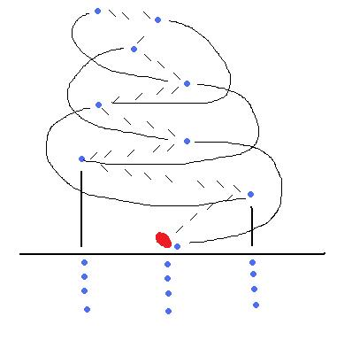 | Next time I would have less waiting time by making more lines.
10 mins.  8:42-8:52 | Task # 2: 3 Man Weave (with frisbee) | People = same  Spacing = same  Time = same  Equipment = same | The drill will be the same as above, but now it will be with the frisbee.  Students should focus on the following during the drill:  -Lead passing  -Catching while on the move  -Follow your pass  -Move without the frisbee  -Keeping proper spacing
7 mins.  8:52-9:00 | CHECK FOR UNDERSTANDING & LESSON CLOSURE |  | Closing Questions:  What do you think was the purpose of the 3-person weave?  Can you tell me why spacing is important in the game of ultimate frisbee?  Was it more difficult to catch the frisbee on the move?  Assessment: Exit Slip Given (see below)

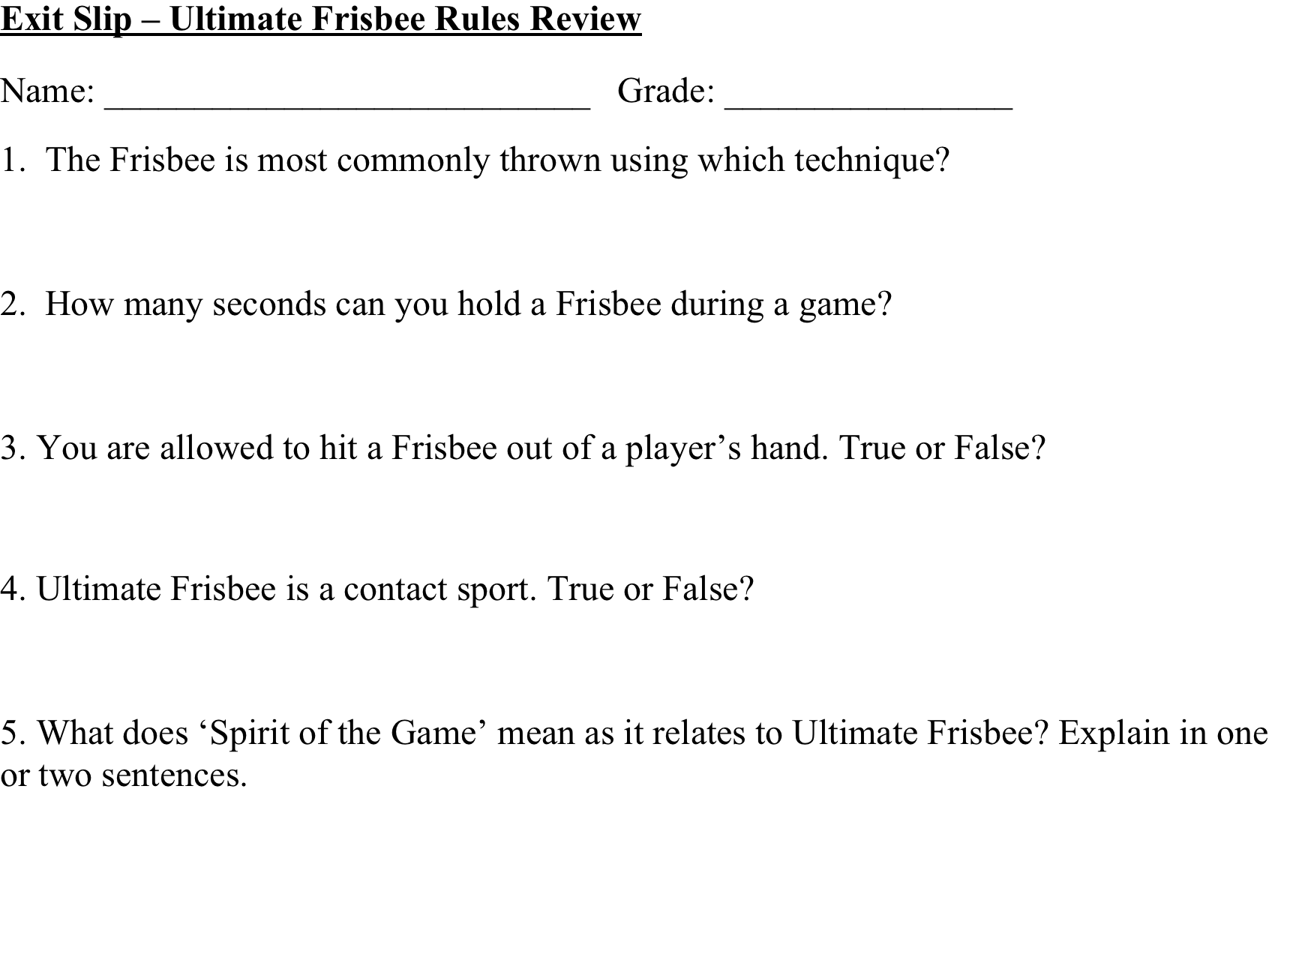
Georgia State University PE Lesson Plan

Name: Kari Hunt | Date: 10/27/2011 | Semester: Fall 2011 | Class: 7240
Class/grade level: 7th |  | Date to be taught: 10/28/11
Unit/Theme: Ultimate Frisbee |  | Lesson #: 5 | Of: 5
# Of students: 28

Skills already developed by students:
At this point, students know how to properly throw and catch the frisbee and know the basic rules of ultimate frisbee.
What happened during last lesson?
Lesson objective (s):
 | Domain | Performance | Situation | Criteria
1 | Psychomotor | SWBAT use frisbee motor skills | During modified game play | 100% of the game
2 | Affective | SWBAT to demonstrate safe behavior and good sportsmanship | During modified game play | As determined by teacher observation

State standard targeted (indicate standard(s), number(s) and write out standard(s)
PE7.1: Demonstrates competency in motor skills and movement patterns needed to perform a variety of physical activities.
PE7.2: Demonstrates understanding of movement concepts, principles, strategies, and tactics as they apply to the learning and performance of physical activities.
PE7.5: Exhibits responsible personal and social behavior that respects self and others in physical
activity settings.
PE 7.6: Values physical activity for health, enjoyment, challenge, self expression, and/or social-
interaction.
Assessment for measuring performance criteria
Teacher will use sliding scale to assess both the psychomotor and affective components of the lesson.
The sliding scale for the affective domain will range from 1 (showed very little to no sportsmanship/safe behavior), 2 (showed mild to moderate sportsmanship/safe behavior) to 3 (showed good to great sportsmanship/safe behavior).
The sliding scale for the psychomotor domain will range from 1 (cannot perform skill), 2 (can perform skill but needs improvement) to 3 (can perform skill very well w/ little to no improvement needed).
My goal for improving my teaching
To make sure I have a balance of instruction, practice, positive feedback, and active engagement for the entire lesson.
Equipment and resources needed
-15 Frisbees minimum (enough for partner drills).
-Cones
-Pinnies
Alternative activities for students with special needs (those unable to participate in regular activities with modifications)
Accommodations will be made if needed.
Instructional / practice time / organization (see other side)

Time | Activity/Task Development/Safety Issues | Organization Management | Critical Elements/Teaching Prompts | Reflection
2 mins.  8:35-8:37  2 mins.  8:37-8:39 | Set Induction (for Task #1)  SIGNALS & DEMONSTRATIONS  (Min. of 2 demos)  Rule Overview | People: Students will be lined up in a semi-circle format outside. | Today we will the culminating event for your unit on ultimate frisbee. We will be using all of the skills that you have practiced all week to play a 7 v 7 game of ultimate. The object of the game is to move the frisbee down the field and get the frisbee into your opponent’s end zone.  The objective for the lesson will be for you to utilize the frisbee skills you have learned in a modified game setting, while exhibiting game strategy, fair play, and good sportsmanship. | If I did this again, I probably would have had 3 games going so we could have played 4 v 4 so each player would get more involved during the game.
15 mins.  8:39-8:54 | Task #1: Modified Ultimate Frisbee Game  Teacher Observation – Assessment of Psychomotor & Affective Domain with Sliding Scale. | People = 7 v 7 (2 games going on)  Spacing = 2 separate fields  Time = 15 minutes  Equipment = 2 frisbees. Cones will mark boundaries of fields. | Important Rules:  - Players must catch the frisbee in the end zone in order to score a point.  - A throw off initiates the game, which means one team throws from their endzone. All players must be in the endzone before the disc is thrown.  - Players are only allowed to hold the disc for 10 seconds before passing it.  - Defenders may count aloud the 10 seconds so the thrower is aware of how much time they have to throw the Frisbee.  - When in possession of the Frisbee a player is only allowed to take 3 steps of movement, after which a pass to a teammate becomes necessary.  - Every incomplete pass results in a turnover and immediately changes possession of the frisbee to the other team.  - When guarding a player from the other team give them an arm’s distance of space. This is not a contact sport.
6 mins.  8:54-9:00 | CHECK FOR UNDERSTANDING & LESSON CLOSURE |  | Closing Questions:  Students will be asked what they learned from the unit this week in all domains:  Cognitive Learning  Psychomotor Learning  Affective Learning  Students will be asked for suggestions and/or improvements they may have for the lessons and/or unit.

